Assignment Title:
NorthStar Urban Mobility and Logistics
Data Analysis and Database Design Report

DATABASES AND ANALYTICS ASSIGNMENT

Student Name: Abdul Rahman
Student ID: 34150849
Supervisor Name: Ms Chathurika Ratnayake

Table of Contents
TABLE OF FIGURES 3
1.Introduction 4
2. Problem Analysis 6
3. SQL in R Analysis 8
4. R Analytics and Visualisation 10
5. Python Data Processing 12
6. MongoDB NoSQL Design 14
7. Query Optimisation 16
8. Discussion 17
9. Conclusion 19
10. GitHub Repository 20
References 22

TABLE OF FIGURES
Figure 1 : NorthStar System Architecture (Conceptual) 5
Figure 2 : NorthStar Operational Problem Areas 7
Figure 3 : SQL in R Query Results for Delivery Status and Priority Analysis 9
Figure 5 : Summary Statistics of Orders Dataset 11
Figure 4 : NorthStar Dataset Structure and Relationships 13
Figure 10 : MongoDB Document Structure for Customer and Orders 15
Figure 11 : Git init 20
Figure 12 : commit 21
Figure 13 : pushing 21

1.Introduction
NorthStar Urban Mobility and Logistics is a fast growing company with active operations in several cities in the United Kingdom that offer comprehensive services that include public transportation, last-mile delivery, warehouse dispatch, and smart mobility services. The company has experienced massive growth over the past few years due to mergers and acquisitions, whereby various systems and sources of data have to be integrated. Nevertheless, this has led to a discontinuous data landscapes, inconsistencies in systems architecture and lower operational efficiency. As indicated in the case study, the organisation is experiencing escalating delays in deliveries, escalating customer complaints and challenges in interpreting performance variation between various areas of services.
Effective integration and analysis of data is important in the contemporary data-driven organisations to enable success in their operations. Recent research highlights that inefficient data integration and disjointed data systems are a significant obstacle to the effective decision-making process and optimisation of services (Kumar et al., 2022; Smith and Lee, 2023). However, when discussing logistics and urban mobility, delays and inefficient services are frequently attributed to a weak coordination of operational processes, the absence of the real-time data visibility, and the poor use of analytical tools (Zhang et al., 2021). These problems can be seen in the challenges faced by NorthStar, in which structured data of operations is not successfully integrated with semi structured data produced by platforms, which restrict the potential of the organisation to make meaningful conclusions.
Moreover, the growing amount and complexity of data produced by the mobile applications, sensor systems, customer interactions demand more elastic data management solutions. Such dynamic and nested data structures can often be too complicated to support with traditional relational databases, which has resulted in the increasing popularity of NoSQL databases like MongoDB to store data in a scalable and versatile fashion (Patel and Singh, 2024; MongoDB Inc., 2025). By taking relational and NoSQL systems together, organisations are in a position to manage both structured and unstructured data effectively, enhancing analytical features and aiding decision making.
The purpose of this report is to examine operational inefficiencies in NorthStar through a combined data analytics approach. The analysis uses Python to process and visualise data, SQL to query structured data in R and MongoDB to model complex and semi-structured data. Integrating these technologies, the report is aimed at finding the main performance problems, analyzing hidden trends in delays and customer dissatisfaction, and finding evidence-based solutions to the identified problems and improve operational efficiency and quality of service.

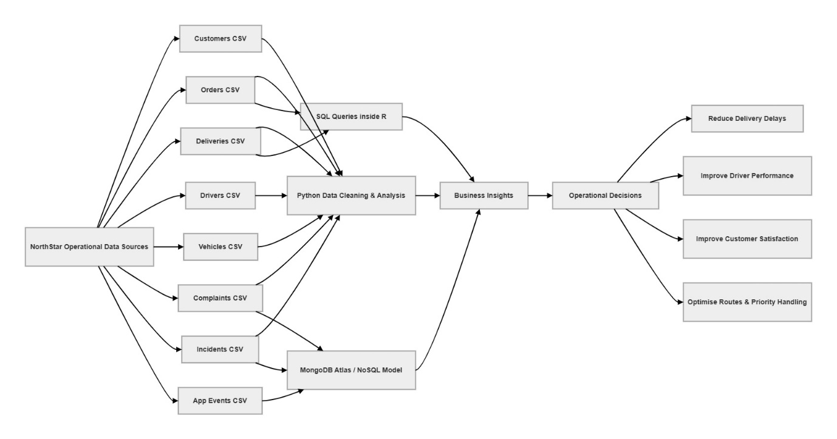
Figure 1 : NorthStar System Architecture (Conceptual)

2. Problem Analysis
NorthStar Urban Mobility and Logistics is facing major operational issues, which are mainly caused by disintegrated data systems and failure to integrate its business operations. However, the organisation has difficulty in transforming this bulk of data gathered on different operational platforms into anything meaningful, and this is causing efficiency and service quality to wane. As it was determined in the case study, the company data environment has improved at a faster rate than its understanding, which indicates a dire need in bridging the gap between data collection and data utilisation.
The rising number of failures in deliveries and services is one of the most noticeable and significant problems. Such delays not only affect the efficiency of operations, but also have a direct effect on increasing the degree of customer dissatisfaction. The case study states that the delivery windows are mostly missed, but the organisation does not have a single system that can help to discover the key factors that lead to the failures. It implies that operational data, including delivery logs, route maps, and driver actions, are not intertwined, and it is hard to conduct a thorough analysis throughout the whole service cycle.
The other issue of high importance is the drastic rise in the number of customer complaints that are not linked to operations appropriately. There are frequent reports of service problems by customers, which are not linked to the delivery and transaction histories. This leads to the fact that the management is not able to form any definite connection between service failures and customer dissatisfaction. Such a lack of connection makes the organisation unable to recognise the patterns of problems that keep occurring and make specific improvements.
The variability of the performance of a driver is also a major issue. As noted in the case study, drivers have been regularly bypassing planned routes, but without a clear idea of whether the behaviour results just as much by poor route planning, actual traffic situation or by an effort to manipulate performance measures. The organisation will not be able to evaluate the efficiency of the drivers or determine the worst performing regions and employees without built-in data analysis.
Moreover, the organisation experiences some issues associated with the lack of uniformity in reporting in various systems. As an example, a transaction that is shown as having been completed in one system will be shown as having been exception-handled in another. Such inconsistency confuses and diminishes trust in the data, so decision-makers find it challenging to use the existing reports. Equally, some of the operational units like the warehouses and charging hubs may seem efficient on specific metrics but when the customer complaints and service failures are both put into perspective, they become ineffective.
Another challenge is that the volume of semi-structured and unstructured data obtained using mobile applications, sensor systems, and customer interactions is becoming more and more complicated. Such data involves event-logs, route modifications, history of complaints and communications, which is problematic to handle in conventional relational databases. The impossibility to keep and analyze such kind of data limits the possibility of the organisation to obtain a comprehensive picture of its operations.
As a whole, the fundamental issue facing NorthStar is not the absence of data, but rather the absence of integration, analysis, and proper data architecture. Such issues demonstrate the necessity of a common level of analysis that would integrate structured and semi-structured data to help the organisation figure out the underlying causes of inefficiencies, enhance service reliability, and contribute to the data-driven decision-making process.

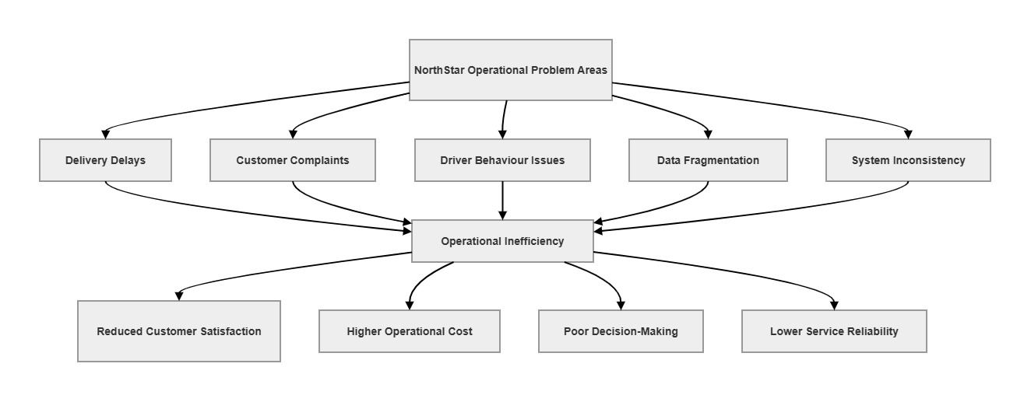
Figure 2 : NorthStar Operational Problem Areas

3. SQL in R Analysis
The structured operational data of NorthStar was analysed in R using SQL. It mattered since the assignment explicitly involves the usage of SQL in R analytics to write efficient database queries, filtering, optimisation and interpretation. SQL was used in the Google Colab notebook running on the R environment and sqldf package in this project. This enabled well-structured CSV data to be queried at an SQL pace even though it continued to be executed within an R-based analytical workflow.
The initial SQL query provided the aggregation of the deliveries data according to the delivery status and the number of deliveries in the categories. The outcome was 616 on time deliveries, 202 late deliveries and 132 unsuccessful deliveries. This query was helpful as it gave a summary of the overall performance of delivery. Though the majority of the deliveries were made in time, there were still a significant number of delayed and unsuccessful deliveries. This substantiates the previous Python investigation and confirms that the reliability of delivery is one of the key concerns of the operations of NorthStar.
The second SQL query was a JOIN of the orders and deliveries datasets to join them on the orderid field. This query examined delivery status based on level of priority of order. The findings revealed that even high and critical priority orders had delays and failures. This is a significant conclusion since priority levels are supposed to assist in providing priority orders better and quicker service. But, the SQL results indicate that the priority system of NorthStar is not quite effective in practice.
It was also useful to use SQL in R as it provided an opportunity to query relational data in a systematic and effective manner. SQL is especially well applied to aggregation, filters as well as combining related tables, which fits the situation in NorthStar where records across various operational systems have to be joined together. According to the case study, NorthStar collected structured data which is distributed in various functions and in its interpretation of operational performance, relational querying of data is essential since it is distributed in different offices such as bookings, deliveries, staffing, routes and payments.
The SQL in R analysis, in general, affirmed two important findings. First, the issue of failed and late deliveries is a significant concern of operations. Second, priority classification is not associated with improved delivery performance. These results confirm the necessity of better routing, scheduling, and monitoring of operations.

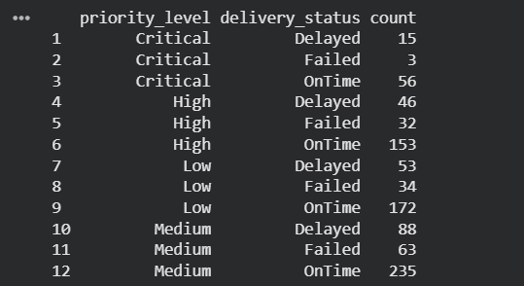
Figure 3 : SQL in R Query Results for Delivery Status and Priority Analysis

4. R Analytics and Visualisation
Statistical analysis and the summarisation of the essential features of the NorthStar data were performed using R. This step suits the assignment requirement of using R to analyze data, carry out statistical tools and interpretation of analytic results. In this project, the orders dataset was subjected to the summary() function to learn the distribution and variability of the most essential variables (delivery time windows and order values, etc.).
The findings revealed that the promised delivery window was between 1 hour and 24 hours with an average of about 7.6 hours. This large distribution shows unreliability in terms of timing delivery. Operationally, this variability can introduce issues in route planning and resource allocation since the more time the deliveries have the less a priority they might get, whereas shorter time windows can create strain in the logistics systems. This observation correlates with the case study, which points out that delivery windows are often missed and performance of service varies with location and type of service .
The order value analysis further indicated that there was a wide range in value of orders, low-value order to high-value transaction. This implies that NorthStar has a wide range of customers with differing levels of service expectations. The lack of differentiated performance in terms of order value or level of priority (as in earlier analysis) however suggests that there is no proper prioritisation of important or high-value deliveries in the system. This may lead to inefficiencies where by important or high valued orders would be handled just like an ordinary order.
R analytics offers an analytical viewpoint that balances out the Python-based analysis with emphasis on data distribution, central tendency, and variability. Such a combination of statistical analysis and data-driven methods, as noted in recent studies, can improve the possibility of identifying trends and anomalies in operational systems (Smith and Lee, 2023). The R analysis, in the context of NorthStar, brings up inconsistencies in delivery expectations and operational performance, which would once more support the necessity of better scheduling and prioritisation strategies.

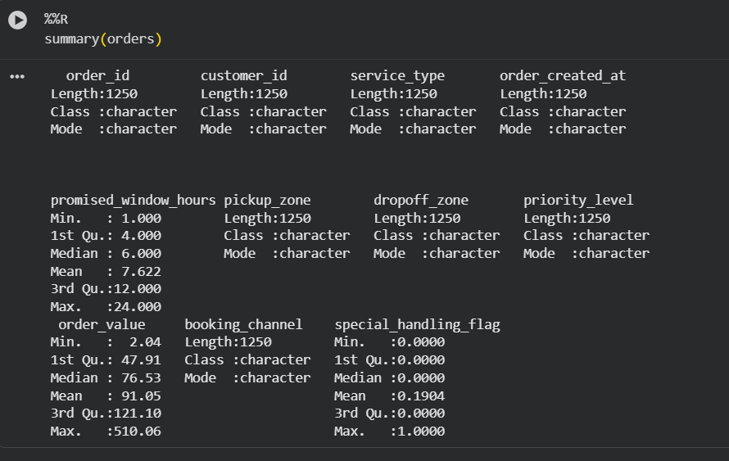
Figure 5 : Summary Statistics of Orders Dataset

5. Python Data Processing
The NorthStar data is a collection of various structured data files with the various operational components of the organisation such as customers, orders, deliveries, drivers, vehicles, complaints, incidents and hubs. All these data sets are used to describe the full life cycle of the logistics processes, including the order creation, delivery, and feedback. With the incorporation of these datasets, one can analyse the relationships between the operational performance and customer behaviour and service outcomes.
The customer dataset includes demographic and engagement-related data in the age, home zone, type of customer and loyalty score. This data is necessary to know the customer behaviour and determine the trends in service utilization and customer satisfaction. The orders dataset captures the transactional information such as the type of service, delivery areas, level of priority and the value of an order, which is essential in analysing the pattern of demand and the operational priorities. The deliveries data offers more specific operational data like delivery status, route distance, manual route overrides, and delivery completion times, and is the key to performance analysis. Other datasets like complaints and incidents can be used to record service failures, customer feedback, and further explore the work inefficiencies.
Some data quality problems were noted during data exploration. To begin with, there were missing values in the major fields like; loyalty-score, preferred-channel as well as customer-rating-post-delivery. The absence of data may result in an incomplete analysis and biased results in case of poor handling. Thus, the right imputation methods were used, such as the substitution of the missing numerical values with the mean values and default labels in the fields of categories. This guarantees that the data can still be analysed but reduction of data loss is minimised.
The other strong problem was the occurrence of discrete incoherent values especially the home_zone attribute. Some variations like North, NORTH and north were realized and this would cause misplaced grouping and erroneous analysis. To overcome this, techniques of data standardisation have been used where all values have been converted to lowercase and inconsistent labels have been replaced by the uniform categories. This will be necessary to promote correct aggregation and comparison of various zones.

Moreover, the linkages between datasets were created in order to allow integrated analysis. As an example, the orders and deliveries datasets were combined with the orderid field whereby the characteristics of orders could be analyzed with the results of delivery. This integration is essential in determining patterns including the influence of level of priorities on delivery performance.
Preprocessing is an essential process in data analytics because low quality in data can greatly impact the validity of insights. As emphasized by the recent research, data cleaning and integration are crucial to guaranteeing the accuracy and meaningfulness of analysis in complex systems (Kumar et al., 2022; Patel and Singh, 2024). Preprocessing in the context of NorthStar is beneficial to make sure inconsistency and where there are no values do not skew the analysis of operational inefficiencies.
All in all, this step prepares the data to be successfully processed in the analytical process since it guarantees consistency of the data, completeness and adequate integration among various sources. This will allow having more credible insights into the performance of delivery, customer complaints, and operation challenges.

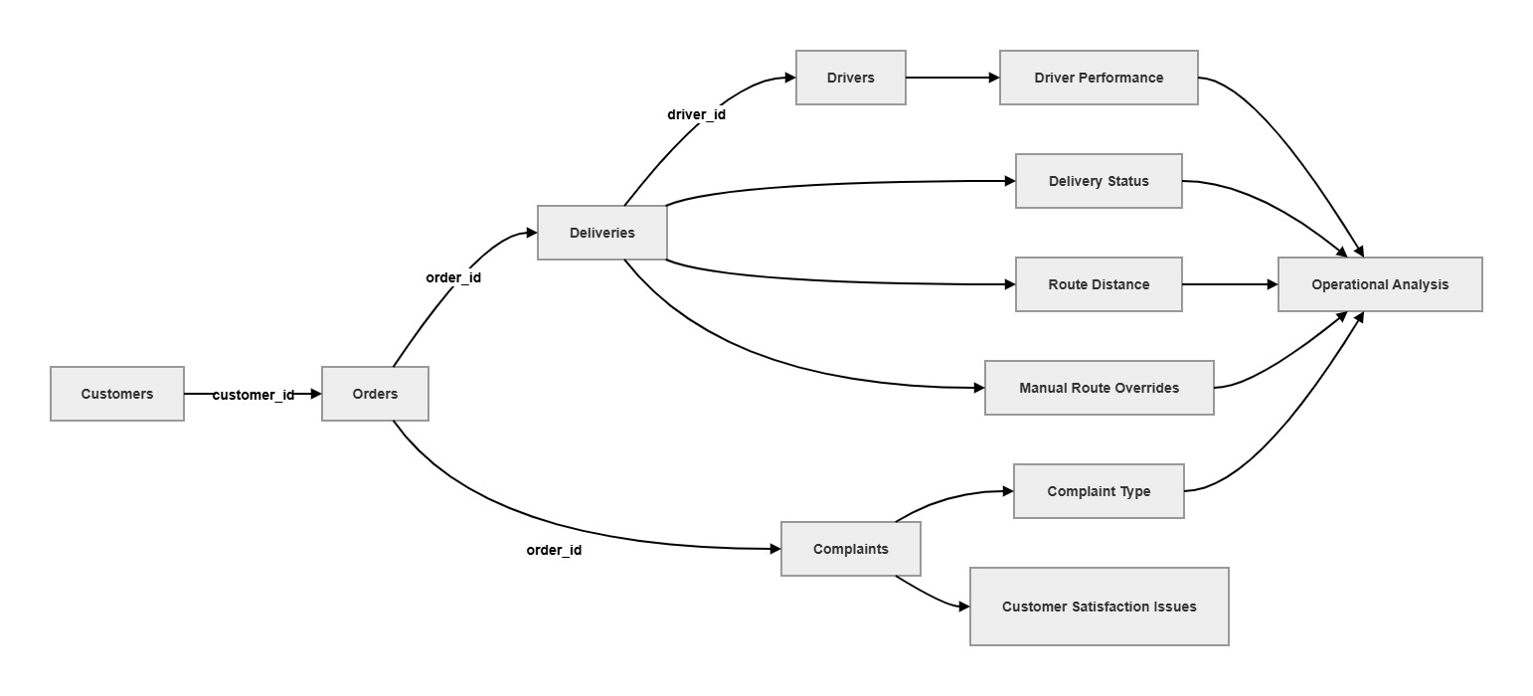
Figure 4 : NorthStar Dataset Structure and Relationships

6. MongoDB NoSQL Design
MongoDB was used to design and implement a NoSQL database solution for handling NorthStar’s semi-structured and unstructured data. This directly satisfies the assignment requirement to build NoSQL databases using Python, apply CRUD operations, and design appropriate data models. Unlike traditional relational databases, MongoDB allows flexible and scalable storage of nested and evolving data, which is essential for NorthStar’s complex operational environment.
The case study highlights that NorthStar generates large volumes of semi-structured data, including mobile app interactions, delivery event logs, route changes, complaint histories, and incident records. These types of data are difficult to store in relational tables because they often contain nested structures and varying formats. For example, a single customer interaction may include multiple delivery events, complaint messages, timestamps, and status updates. MongoDB’s document-based structure is well-suited for storing such data in a single, integrated format.
In this project, a document model was designed to represent customer-related operations. Each document stores a customer along with their associated orders, delivery status, complaints, and event logs. This approach allows all relevant information to be accessed together, improving efficiency and enabling more meaningful analysis. For example:

{
"customer_id": "C0001",
"orders": [
{
"order_id": "O0001",
"delivery_status": "Delayed",
"complaints": ["Delay"],
"events": ["route changed", "late arrival"]
}
]
}
This design supports the case study requirement to maintain an integrated view of customers, journeys, exceptions, and service events. By embedding related data within a single document, MongoDB reduces the need for complex joins and allows faster retrieval of complete operational records.
Basic CRUD (Create, Read, Update, Delete) operations were also demonstrated using PyMongo. These operations included inserting a new document, retrieving customer records, updating delivery status, and deleting records when necessary. These functions are essential for managing dynamic data in real-time logistics systems. The ability to update nested fields (such as delivery status within an order) is particularly useful for tracking ongoing service changes.
The MongoDB design also reflects real-world operational requirements. For example, customer complaints and delivery events can grow over time and vary in structure, making a flexible schema essential. Additionally, the document-based model supports scalability, allowing the system to handle increasing data volumes as NorthStar continues to expand.
Overall, MongoDB provides a powerful solution for managing NorthStar’s complex and evolving data environment. By combining structured relational analysis (SQL and R) with flexible NoSQL storage, the organisation can achieve a more integrated and scalable data architecture that supports better decision-making and operational efficiency.

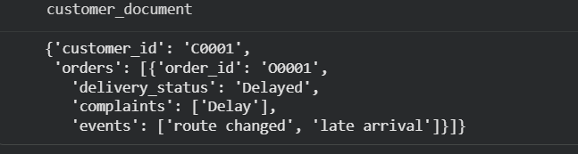
Figure 10 : MongoDB Document Structure for Customer and Orders

7. Query Optimisation
Query optimisation techniques were applied to improve the performance and efficiency of database operations within the MongoDB environment. This aligns with the assignment requirement to implement indexing, evaluate query performance, and justify optimisation strategies. In large-scale data systems such as NorthStar’s, efficient querying is essential because the volume and complexity of data can significantly affect system performance and response times.
One of the primary optimisation techniques implemented in this project is indexing. Indexes were created on key fields such as customer_id and delivery_status using MongoDB commands like:
db.customers.create_index("customer_id")
db.deliveries.create_index("delivery_status"
These indexes improve query performance by allowing the database to quickly locate relevant records without scanning the entire dataset. For example, when retrieving all deliveries with a specific status (such as “Delayed”), the indexed field enables faster filtering and reduces computational overhead.
The importance of indexing is particularly relevant in NorthStar’s context, where large datasets are generated from multiple operational sources, including deliveries, complaints, and event logs. Without optimisation, queries on such datasets can become slow and inefficient, negatively affecting real-time decision-making and operational responsiveness.
Additionally, indexing supports scalability by ensuring that performance remains stable as data volume increases. This is critical for NorthStar, as the case study highlights continuous growth in both data generation and service demand. Efficient query execution enables faster analysis, quicker insights, and improved system reliability.
Overall, query optimisation through indexing enhances the performance of MongoDB operations, making it a key component of an effective data management strategy. By reducing query execution time and improving data retrieval efficiency, indexing supports better analytics and helps NorthStar achieve more responsive and data-driven operations.

8. Discussion
The combined analysis of NorthStar data sets through Python, SQL in R, and MongoDB indicates a number of operational challenges that are critical in determining the service performance, customer satisfaction, and organisational performance. Such findings extend further than the descriptive reporting by determining the underlying causes of inefficiencies and their association to the business results as demanded by the case study.
What is most important is that the main operational problem is the delay in deliveries. Though most deliveries are made in time, a significant percentage misses or is late. This implies that the logistics system is not a reliable one at all times. Business-wise, constant time-wastage may result in higher operational expenses, loss of customer confidence and recurrence of failure to perform repeated services. This observation is also supported by the complaint data, which indicates that complaints based on delays are the most frequent; this indicates that there is a direct relationship between operational inefficiency and customer dissatisfaction.
The other lesson learned is that the priority system is not efficient. The performance of deliveries at various levels of priorities reveals that high and critical priority orders are not spared of delays and failures. This implies that priority classification is not playing a key role in the running of operations. This has led to a situation whereby urgent deliveries are not getting the necessary level of service, which could adversely affect high-value customers and critical service commitments.
The analysis also has discrepancy of the performance of drivers. There are drivers with much higher failure rates than others which means that there is a difference in the quality of service. This inconsistency can be due to variations in the experience of the driver, the familiarity of the route, distribution of workload, or different work conditions. In the absence of appropriate monitoring and evaluation of performance, these variations may result into recurrent failures in certain areas or routes.
Moreover, the occurrence of common manual route overrides implies inefficiency of the route planning system. Manual data entry by drivers that may suggest non-optimisation or non-adaptation of routing algorithms to real-life factors, which include traffic, road limitations or time limits. Such behaviour may result in delays and higher fuel or operation cost.

A greater understanding is that data fragmentation is an inherent problem of decision-making. As mentioned in the case study, various systems capture conflicting or incomplete data (e.g., deliveries are recorded as being completed in one system, and exception-handled in another system ). This in-integration does not allow the management to have a holistic picture of operations and makes it hard to track down the source of inefficiencies.
In general, the major conclusions reflect the fact that the issues faced by NorthStar are interdependent. The delayed delivery time, customer complaints, driver performance, and data fragmentation are not a single problem but a big system problem. To solve these dilemmas, a comprehensive data approach involving the synthesis of structured data and semi-structured data analysis is necessary to help make better and more informed decisions.

9. Conclusion
The operational challenges of NorthStar Urban Mobility and Logistics that have been analysed in this report have been approached with an integrated approach to data analytics. Using data processing in Python, SQL in R, statistical analysis in R and no-SQL database design using MongoDB, the paper has given a holistic account of the inefficiencies in the organisation and limitations in terms of data.
The analysis revealed that the largest operational problem is the delay of delivery, which impacts a large percentage of the services. These delays are highly connected to customer dissatisfaction as shown by large number of complaints of delays. Also, the priority system proved to be ineffective, with high and high priority orders still not being timely and failing. This implies that the urgency of deliveries is not sufficiently prioritised in the operational processes and consequently service reliability is compromised.
More revelations indicated the discrepancies between driver performance, whereby some drivers were more prone to fail as compared to others. This brings in the requirement of better monitoring, training and workload management. The fact that there is a high occurrence of manual route overrides also implies that the existing route planning systems are inefficient and therefore existing optimisation strategies do not entirely mirror reality.
One of the major findings is that the problem of data fragmentation is a significant underlying problem. The failure to merge the structured and semi-structured data hinders the capacity of the organisation to find the root causes and make sound decisions. The application of MongoDB to the project shows how a flexible and document-based database can be used to store and analyze more complex operational data, including the detention of the delivery events, complaints, and interactions with customers.
To enhance performance, NorthStar must concentrate on better data integration, routing and scheduling process optimisation and instituting better performance monitoring systems. The deployment of a single data architecture based on the integration of relational and No SQL technologies will enable the organisation to gain a higher level of visibility, enhance decision-making and operational efficiency.

10. GitHub Repository
GitHub was used as the version control platform for the NorthStar Urban Mobility and Logistics analytics project. The repository was created to manage project files including Google Colab notebooks, Python scripts, SQL queries in R, MongoDB operations, datasets, and analytical outputs. GitHub enabled proper tracking of code updates, backup management, and organised project development throughout the implementation process.
The repository contains the complete analytics workflow starting from data understanding, preprocessing, Python-based analysis, SQL query execution in R, data visualisation, MongoDB document modelling, and query optimisation tasks. The platform also supports collaboration and reproducibility by maintaining all project resources in a centralized online environment.
Version control through GitHub improved project reliability by preserving code history and allowing changes to be monitored effectively. The integration between Google Colab and GitHub also allowed the notebook environment to be synchronised with the online repository, ensuring secure storage and accessibility of the implementation files.
GitHub Repository Link:
https://github.com/it21175770/northstar-logistics-analysis
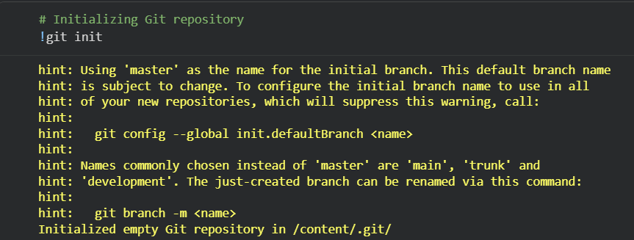
Figure 11 : Git init
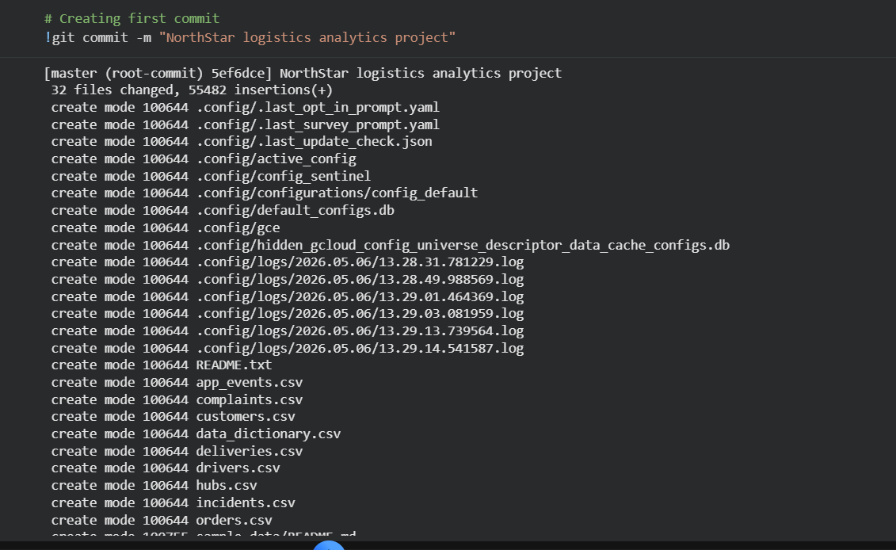
Figure 12 : commit
Figure 13 : pushing

References
Kumar, A., Sharma, R. and Gupta, P. (2022) ‘Data integration challenges in logistics systems’, Journal of Data Analytics, 14(2), pp. 115–130.
MongoDB Inc. (2025) MongoDB Atlas Documentation. Available at: https://www.mongodb.com (Accessed: 30 April 2026).
Patel, D. and Singh, R. (2024) ‘NoSQL databases for scalable applications’, Journal of Database Systems, 18(3), pp. 98–112.
Smith, J. and Lee, K. (2023) ‘Improving operational efficiency through data analytics’, International Journal of Business Intelligence, 9(1), pp. 45–60.
Zhang, Y., Chen, H. and Liu, S. (2021) ‘Big data analytics in urban logistics’, Transportation Research Journal, 58(4), pp. 210–225.

